

**UNIVERSITI MALAYSIA TERENGGANU**

**FACULTY OF COMPUTER SCIENCE AND MATHEMATICS**

**­­­­________________________________________________________**

**CSM3123 - NATIVE MOBILE PROGRAMMING**

**BANCHELOR OF COMPUTER SCIENCE (MOBILE COMPUTING) WITH HONORS**

**LAB 6**

**SEMESTER 5 2024/2025**

**________________________________________________________**

**PREPARED FOR:**

**DR RABIEI B MAMAT**

**PREPARED BY:**

**NUR EZREENA SHUHADA BT EMRAN**

**S66467**

**Link Github:** [**https://github.com/NurEzreena/CSM3123_LAB-NATIVE-PROGRAMMING.git**](https://github.com/NurEzreena/CSM3123_LAB-NATIVE-PROGRAMMING.git)

**Detecting available sensors**

MainActivity.java

|  |
| --- |
| package com.example.sensorexperimentapp;  import android.hardware.Sensor; import android.hardware.SensorManager; import android.os.Bundle; import android.widget.TextViewa; import android.widget.Button;  import androidx.appcompat.app.AppCompatActivity; import java.util.List;  public class MainActivity extends AppCompatActivity {   private SensorManager sensorManager;  private TextView sensorListTextView;   @Override  protected void onCreate(Bundle savedInstanceState){  super.onCreate(savedInstanceState);  setContentView(R.layout.*activity_main*);   Button detectSensorsButton = findViewById(R.id.*detectSensorsButton*);  sensorListTextView =findViewById(R.id.*sensorListTextView*);   sensorManager =(SensorManager) getSystemService(*SENSOR_SERVICE*);  detectSensorsButton.setOnClickListener(v-> listAvailableSensors());  }   private void listAvailableSensors(){  List<Sensor>sensorList = sensorManager.getSensorList(Sensor.*TYPE_ALL*);  StringBuilder sensorInfo =new StringBuilder("Available sensor: \n");  for (Sensor sensor :sensorList){  sensorInfo.append(sensor.getName()).append("(").append(sensor.getType()).append(")\n");  }  sensorListTextView.setText(sensorInfo.toString());  }   } |

Activity_main.xml

|  |
| --- |
| <LinearLayout  xmlns:android="http://schemas.android.com/apk/res/android"  android:layout_height="match_parent"  android:layout_width="match_parent"  android:orientation="vertical"  android:padding="16dp">   <Button  android:id="@+id/detectSensorsButton"  android:layout_width="match_parent"  android:layout_height="wrap_content"  android:text="Detect available sensors" />  <TextView  android:id="@+id/sensorListTextView"  android:layout_width="match_parent"  android:layout_height="wrap_content"  android:text="Sensor will be listed here"  android:paddingTop="16dp"/>   </LinearLayout> |

Output:

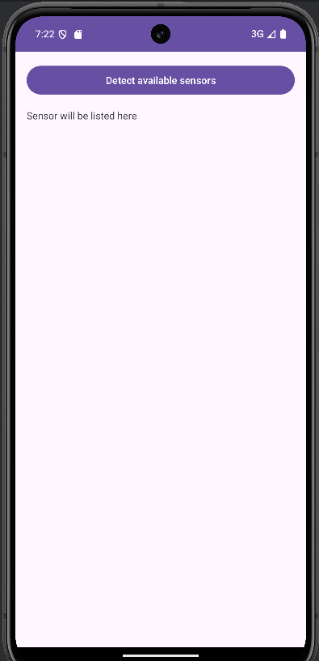 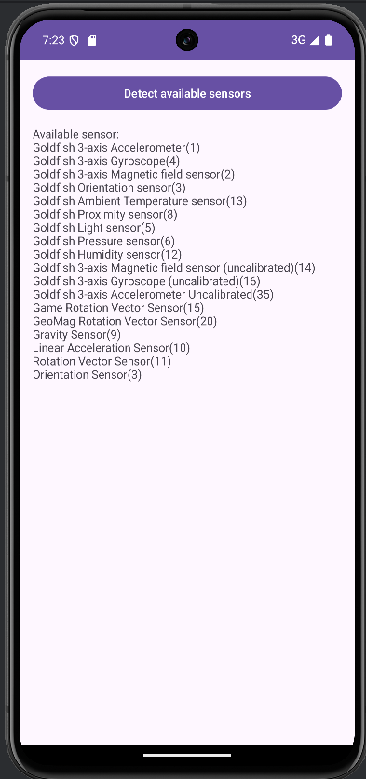

**Experimenting with 3 available sensors**

MainActivity.java

|  |
| --- |
| package com.example.sensorexperimentapp;  import static android.hardware.SensorManager.*SENSOR_DELAY_NORMAL*;  import android.hardware.Sensor; import android.hardware.SensorEvent; import android.hardware.SensorManager; import android.hardware.SensorEventListener; import android.os.Bundle; import android.widget.TextView; import android.widget.Button;  import androidx.appcompat.app.AppCompatActivity;  public class MainActivity extends AppCompatActivity implements SensorEventListener {  private SensorManager sensorManager;  private Sensor accelerometer, proximitySensor, lightSensor;   private TextView accelerometerData, proximityData, lightData;   @Override  protected void onCreate(Bundle savedInstanceState) {  super.onCreate(savedInstanceState);  setContentView(R.layout.*activity_main*);   // Initialize SensorManager  sensorManager = (SensorManager) getSystemService(*SENSOR_SERVICE*);   // Initialize sensors  accelerometer = sensorManager.getDefaultSensor(Sensor.*TYPE_ACCELEROMETER*);  proximitySensor = sensorManager.getDefaultSensor(Sensor.*TYPE_PROXIMITY*);  lightSensor = sensorManager.getDefaultSensor(Sensor.*TYPE_LIGHT*);   // Initialize TextViews  accelerometerData = findViewById(R.id.*accelerometerData*);  proximityData = findViewById(R.id.*proximityData*);  lightData = findViewById(R.id.*lightData*);   // Register listeners for sensors  sensorManager.registerListener(this, accelerometer, *SENSOR_DELAY_NORMAL*);  sensorManager.registerListener(this, proximitySensor, *SENSOR_DELAY_NORMAL*);  sensorManager.registerListener(this, lightSensor, *SENSOR_DELAY_NORMAL*);  }   @Override  public void onSensorChanged(SensorEvent event) {  if (event.sensor.getType() == Sensor.*TYPE_ACCELEROMETER*) {  float x = event.values[0];  float y = event.values[1];  float z = event.values[2];  accelerometerData.setText("Accelerometer Data: X=" + x + ", Y=" + y + ", Z=" + z);  } else if (event.sensor.getType() == Sensor.*TYPE_PROXIMITY*) {  proximityData.setText("Proximity Data: " + event.values[0]);  } else if (event.sensor.getType() == Sensor.*TYPE_LIGHT*) {  lightData.setText("Light Sensor Data: " + event.values[0]);  }  }   @Override  public void onAccuracyChanged(Sensor sensor, int accuracy) {  // No action needed for this example  } } |

Activity_main.xml

|  |
| --- |
| <LinearLayout  xmlns:android="http://schemas.android.com/apk/res/android"  android:layout_height="match_parent"  android:layout_width="match_parent"  android:orientation="vertical"  android:padding="16dp">   <Button  android:id="@+id/detectSensorsButton"  android:layout_width="match_parent"  android:layout_height="wrap_content"  android:text="Detect available sensors" />  <TextView  android:id="@+id/accelerometerData"  android:layout_width="match_parent"  android:layout_height="wrap_content"  android:text="Accelerometer data:"  android:paddingTop="16dp"/>  <TextView  android:id="@+id/proximityData"  android:layout_width="match_parent"  android:layout_height="wrap_content"  android:text="Proximity data:"  android:paddingTop="16dp"/>  <TextView  android:id="@+id/lightData"  android:layout_width="match_parent"  android:layout_height="wrap_content"  android:text="Light sensor data:"  android:paddingTop="16dp"/>    </LinearLayout> |

Output:

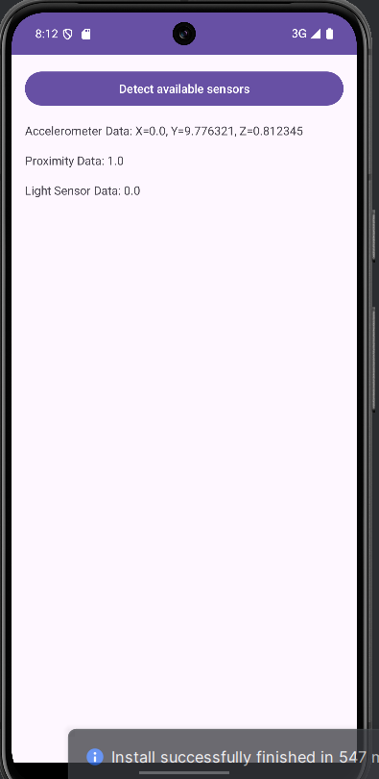

**Sensor Fusion Experimentation**

MainActivity.java

|  |
| --- |
| package com.example.sensorexperimentapp;  import android.hardware.Sensor; import android.hardware.SensorEvent; import android.hardware.SensorEventListener; import android.hardware.SensorManager; import android.os.Bundle; import android.widget.TextView;  import androidx.activity.EdgeToEdge; import androidx.appcompat.app.AppCompatActivity;  public class MainActivity extends AppCompatActivity implements SensorEventListener {   private SensorManager sensorManager; // SensorManager declaration  private Sensor rotationVectorSensor; // Sensor declaration  private TextView orientationData; // TextView declaration   @Override  protected void onCreate(Bundle savedInstanceState) {  super.onCreate(savedInstanceState);  EdgeToEdge.*enable*(this);  setContentView(R.layout.*activity_main*);   // Initialize SensorManager  sensorManager = (SensorManager) getSystemService(*SENSOR_SERVICE*);   // Initialize TextView  orientationData = findViewById(R.id.*orientationData*);   // Initialize Rotation Vector Sensor  rotationVectorSensor = sensorManager.getDefaultSensor(Sensor.*TYPE_ROTATION_VECTOR*);   // Register Sensor Listener  if (rotationVectorSensor != null) {  sensorManager.registerListener(this, rotationVectorSensor, SensorManager.*SENSOR_DELAY_NORMAL*);  } else {  orientationData.setText("Rotation Vector Sensor not available");  }  }   @Override  public void onSensorChanged(SensorEvent event) {  if (event.sensor.getType() == Sensor.*TYPE_ROTATION_VECTOR*) {  float[] rotationMatrix = new float[9];  SensorManager.*getRotationMatrixFromVector*(rotationMatrix, event.values);   float[] orientation = new float[3];  SensorManager.*getOrientation*(rotationMatrix, orientation);   orientationData.setText("Orientation:\n" +  "Azimuth=" + Math.*toDegrees*(orientation[0]) + "°\n" +  "Pitch=" + Math.*toDegrees*(orientation[1]) + "°\n" +  "Roll=" + Math.*toDegrees*(orientation[2]) + "°");  }  }   @Override  public void onAccuracyChanged(Sensor sensor, int accuracy) {  // Not used in this example  }   @Override  protected void onDestroy() {  super.onDestroy();  // Unregister listener to avoid memory leaks  sensorManager.unregisterListener(this);  } } |

Activity_main.xml

|  |
| --- |
| <LinearLayout  xmlns:android="http://schemas.android.com/apk/res/android"  android:layout_height="match_parent"  android:layout_width="match_parent"  android:orientation="vertical"  android:padding="16dp">   <Button  android:id="@+id/detectSensorsButton"  android:layout_width="match_parent"  android:layout_height="wrap_content"  android:text="Detect available sensors" />  <TextView  android:id="@+id/accelerometerData"  android:layout_width="match_parent"  android:layout_height="wrap_content"  android:text="Accelerometer data:"  android:paddingTop="16dp"/>  <TextView  android:id="@+id/proximityData"  android:layout_width="match_parent"  android:layout_height="wrap_content"  android:text="Proximity data:"  android:paddingTop="16dp"/>  <TextView  android:id="@+id/lightData"  android:layout_width="match_parent"  android:layout_height="wrap_content"  android:text="Light sensor data:"  android:paddingTop="16dp"/>   <TextView  android:id="@+id/orientationData"  android:layout_width="match_parent"  android:layout_height="wrap_content"  android:text="Orientation data:"  android:paddingTop="16dp"/>    </LinearLayout> |

Output:

